# SAVING YOUR SPACE SCENE FOR THE CONTEST

1. Open your **Space.PSD** file (NOT Spaceship or step20 or Final)  
   [if you did the additional work covered in Step 21, then open your **STEP21** file]
2. Make sure all of the layers you want included in your space scene are visible  
   [layers with the visibility turned off will NOT be included in the final graphic]
3. Click **File** then click **Save for Web & Devices…**  
   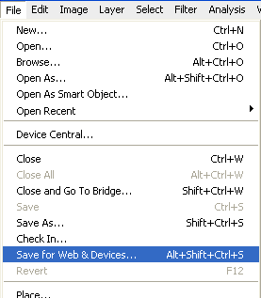
4. In the upper-right hand corner of the Save for Web & Devices window make sure **JPEG** is selected…  
   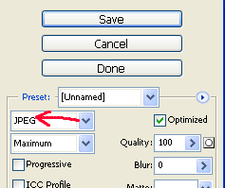
5. Click **Save**
6. Surf to the **Photoshop** folder within your student folder and make the File name your **ID number**
7. Click **Save**